Exercises Predicate Resolution
Exercise 1
Transform the following formulas into prenex, Skolem and clausal normal forms.
- ;
- ;
- ;
- ;
- ;
- ;
- ;
- .

Exercise 2
Are the literals from the following pairs unifiable? If yes, find their most general unifier.
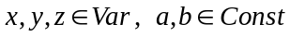, 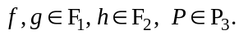
- 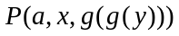 and 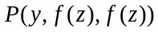;  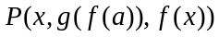 and 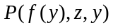;  and 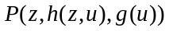 | - 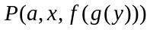 and ;  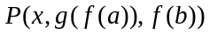 and 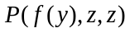;  and 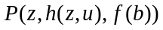;
- 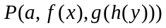 and 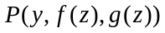;  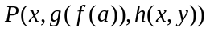 and 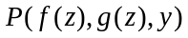;  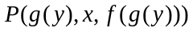 and 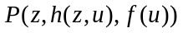; | - 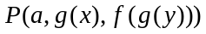 and 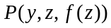;  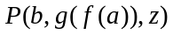 and 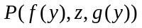;  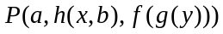 and ;
- 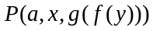 and 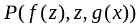;  and 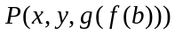;  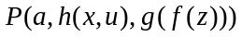 and 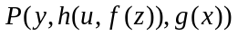; | - 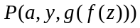 and 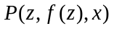;  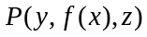 and 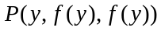;  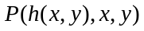 and 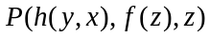;
- and 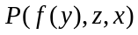;  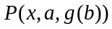 and 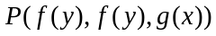;  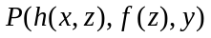 and 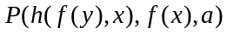; | - and 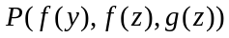;  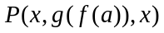 and 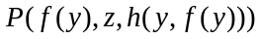;  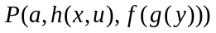 and 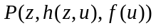

Exercise 3
Prove the inconsistency of the following set of clauses using lock resolution.
Try two different indexings for the literals.
- ;
- ;
- ;
- ;
- ;
- ;
- .

Exercise 4
Using a refinement of predicate resolution prove:

- the semidistributivity of ‘’ over ‘’: | - the semidistributivity of ‘’ over ‘’:
 | - the semidistributivity of ‘’ over ‘’:
- the distributivity of ‘’ over ‘’:
.
7. the distributivity of ‘’ over ‘’:  ; | 8.

Exercise 5
Check whether the following formulas are theorems or not using predicate resolution.

- ;  - ;  - ; | - ;  - ;  - ;  - .

Exercise 6. Succession to the British throne
Hypotheses:
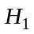. If is the king and is his oldest son, then can become the king.
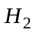. If is the king and defeats , then will become the king.
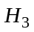. 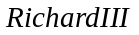 is the king.
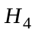. 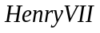 defeated .
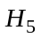. 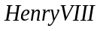 is ’s oldest son.
Conclusion:
. Can become the king?
Check whether the conclusion is derivable from the set of hypotheses {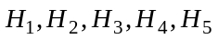}
using linear predicate resolution. 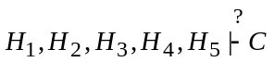.

Exercise 7.
Hypotheses:
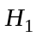: All hummingbirds are richly colored.
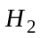: No large birds live on honey.
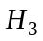: Birds that do not live on honey are dull in color.
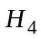: Piky is a hummingbird.
Conclusion:
C: Piky is a small bird and lives on honey.

Using linear predicate resolution check whether the following deduction holds:


